Chapter 9, Solution 81.

Let 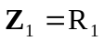, 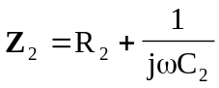, 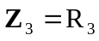, and 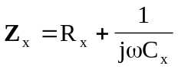.
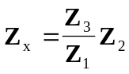
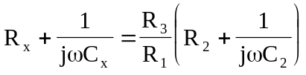

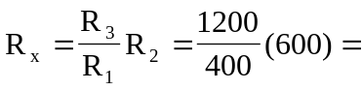 1.8 k

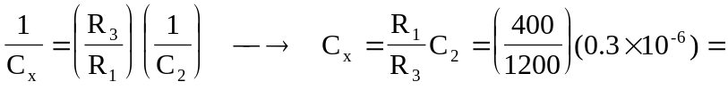 0.1 F

